**Problem**

How to install the Backup Exec Desktop and Laptop Option desktop agent

**Solution**

The desktop agent resides on desktops and laptops that need to be protected.  
  
The installation files for the Desktop and Laptop Option (DLO) desktop agent get copied when installing DLO from the Backup Exec (tm) installation CD. The share called **DLO Agent** automatically gets created on the media server that contains the installation files for the DLO desktop agent.   
  
The desktop agent can be installed on systems running Microsoft Windows 2000 Professional and Microsoft Windows XP Service Pack 1 (SP1) or later. The Desktop Agent can be installed from the Backup Exec for Windows servers Administration console or from the user's desktop computer.  
  
**Note:** The desktop agent is not supported on Windows 95, Windows 98, Windows Millennium Edition, Windows NT or Server operating system, including Windows Server 2003, Windows Storage Server 2003, and Windows 2000 Server. An error message will be displayed if installation of the DLO Agent is attempted on one of these operating systems (Figure 1).  
  
**Figure 1**  
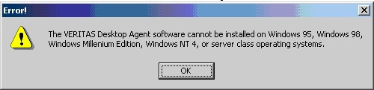  
  
Perform the following steps to install the DLO Desktop Agent from the desktop:  
  
1. Go to the desktop on which the DLO Desktop Agent needs to be installed. Logon as a user with administrative rights to the computer where the Desktop Agent is to be installed. Browse to the network share where the Desktop Agent install set is stored.   
The default path is:**\\<Backup Exec media server name>\DLOAgent** (Figure 2).

**Figure 2**  
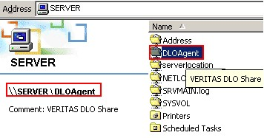  
  
2. Double-click the file **setup.exe**  
  
3. Click **Next** on the Welcome screen  
  
4. Read the license agreement, and select **I accept the terms in the license agreement**. Then click **Next**.  
  
5. Type the desktop user's name and organization name, and then click **Next**  
  
6. Select either **Complete** or **Custom**, and then click **Next** (Figure 3).  
Use the **Complete** option to install all of the Desktop Agent features in the default location **C:\Program Files\VERITAS\Backup Exec\NT\DLO**.  
  
Use the **Custom** option to change the location on the desktop's local drive where the Desktop Agent will be installed, or to select the installation set for a language other than English. The **Custom** option is recommended for advanced users only.  
  
**Figure 3**  
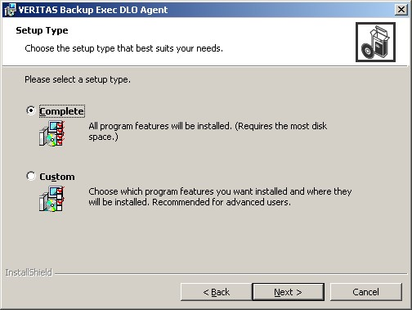  
  
7. Click **Next** after making either of the above selections  
  
8. Click **Install** (Figure 4)  
  
**Figure 4**  
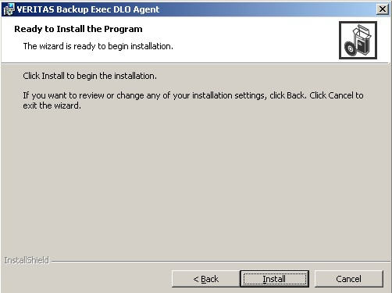  
  
The install process will start (Figure 5).  
  
**Figure 5**  
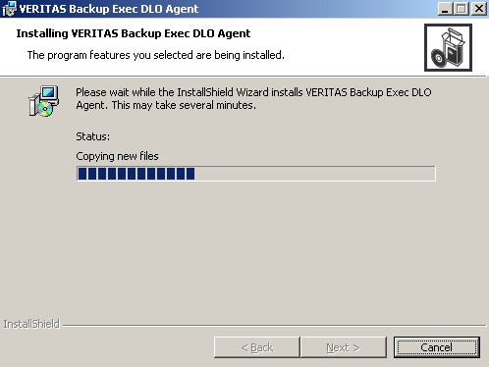  
  
9.Click **Finish**. The Desktop Agent is installed on the desktop.  
  
After completing the above steps, Backup Exec DLO Agent services will be shown as indicated in Figure 6.  
  
**Figure 6**  
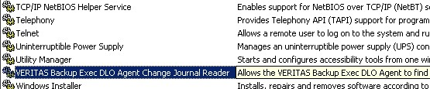  
  
Figure 7 shows a program group for the Backup Exec DLO Agent created.  
  
**Figure 7**  
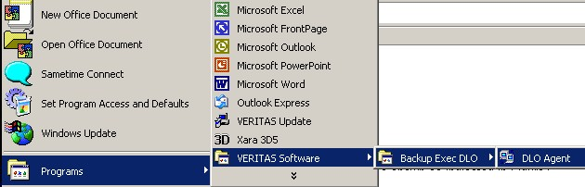

/apps/media/inquira/resources /resources

|  |  |  |
| --- | --- | --- |
|  | |  | | --- | |  | |
|  | | |

**Related Articles**

* [TECH28584 Desktop and Laptop Option (DLO) components must authenticate to the domain that the DLO server resides on.](http://www.symantec.com/business/support/index?page=content&id=TECH28584)

**Legacy ID**

264952

Article URL http://www.symantec.com/docs/TECH29835